Course MS 6510

Business Research Methods

Final Project Group Assignment
The Influence of Corporate Social Responsibility on customer intention to use DTAC service

Submitted to instructor

Dr. Piyathida Praditbatuga

Group Members
Ms. Pajaree Kosuwan I.D. 5671007
Ms. Jaratporn Jantarawong I.D. 5771004
Mr. Karn Petchvaroon I.D. 5772007
Mr.Pras Prasong I.D. 5772009

Master of Science in Management
Semester 02/2015
Graduate School of eLearning Assumption University

TABLE OF CONTENTS

TABLE OF CONTENTS 2
LIST OF FIGURES 3
LIST OF TABLES 4
CHAPTER 1: INTRODUCTION 5
1.1 Background of the Study
1.2 Statement of Problem
1.3 Research Objectives
1.4 Research Questions
1.5 Significance of Research
1.6 Scope of the Research
1.7 Limitation of Research
1.8 Definition of Terms
1.9 Organization of reserach
CHAPTER 2: LITERATURE REVIEW
2.1 Backgraound of DTAC
2.2 Brief overview of CSR activities of DTAC
2.3 Corporate social responsibility (CSR)
2.4 Corporate social responsibity theory
2.5 Consumer behavior theory
2.6 Consumer Behavior in relation to CSR
2.7 Conceptual Framework
2.3 Research Hypotheses
2.4 Concepts and Operationalization of Variables
CHAPTER 3: RESEARCH METHODOLOGY
CHAPTER 4: RESEARCH RESULT
CHAPTER 5: DISCUSSIONS AND RECOMMENDATIONS
BIBLIOGRAPHIES
APPENDIX
Appendix B: Questionnaire (English Version)
Appendix C: Questionnaire (Thai Version)

LIST OF FIGURES

Figure 1: Carroll’s CSR Pyramid……………………………………………………..……………………
Figure 2: A step-wise of Consumer Buying Decision Process……………………………….
Figure 3: Conceptual Framework……………………………………………………………………….

LIST OF TABLES

Table 1: Concept and Operationalization of variables………………………….
Table 2: Reliability Testing Result……………………………….
Table 3: Reliability Testing for Economic Responsibilities
Table 4: Reliability Testing for Legal Responsibilities
Table 5: Mean Score Interpretation
Table 6: Respondents level for Consumer Behavior
Table 7: Respondents level for Economic Responsibilities
Table 8: Respondents level for Legal Responsibilities
Table 9: Respondents level for Ethical Responsibilities
Table 10: Respondents level for Philanthropic Responsibilities
Table 11: Multiple Linear Regression Result

Chapter 1 Introduction

- Background of the Study

Today the global economic was changed into rapid development of the society, the change of society change the behavior of consumer to aware of enterprise. Enterprises have been expected to take more social responsibility. According to the increasing pressure companies have been showing good corporate responsibility in many countries which companies operate their business (Morsing and Beckmann, 2006).

Nowadays, companies perform ethical, economic and legal not only for their shareholder but for their customers, employees and others (Sen and Bhattacharya, 2001). Many enterprises have changed their positioning from profit seeking to social responsible. Corporate social responsibility has become an important point to be concerned by many companies. Since globalization has worked with many companies which establish the acceptance over the social norms of behavior in order to monitors these companies in each country. It is important for a company to take corporate social responsibility (CSR) in their company to deal with the problems about environment protection, sustainable development, human resources management and security (Industry Canada 2012). CSR become important factor for company to achieve the goal for management and to build enterprise competitiveness over the competitor. After the price and quality competition had been concerned, it is time for CSR to become a symbolic of international competition to reach consumer intention. And in the 21 century corporate social responsibility has been viewed as the entry ticket for companies to doing their business (Altman, 2008).

Each companies use different method to create their CSR which related to employee welfare, environment, community, charities and so on. Companies dedicated themselves for CSR practices because they believed that customers would be more supported to the responsible companies (Altman, 2008). Many company believed that consumers’ purchasing behavior may directly influence a company’s performance and development. The consumers’ behaviors and decisions have significant influence on a company’s profit, and they are very important indicators to evaluate a company’s management conditions. There are many methods can help a company to get consumer’ support and purchasing, one effective way is to establish good corporate image in the consumer’s minds.

The corporate’s image in the consumer mind is important because it is a competitive tools to build a company’s sustainable competitive advantage and to build trust from stakeholders, especially for their consumers.

A company can improve their corporate’s mind by fulfilling their CSR. Because the CSR activities of a company can strengthen the company’s mind increase the trust between the company and the consumers, and thus influence their purchasing behavior.

- Statement of the Problem
For a company, one of the most important challenges is to get trust and recognition from their consumers. Whether or not a responsible company could get more support is dependent on the customers’ decision. According to Brown and Dacin (1997), usually consumers’ evaluation of a company’s image and product is paralleled with the company’s corporate social responsibility. Some consumers concerning the CSR initiatives when they buy products, they view CSR as a referential factor for their purchase decision. Meanwhile, they resist the products made by the irresponsible company.

Crowther and Rayman-Bacchus (2003) stated that there are several factors influencing the corporate social responsibility such as top manager, shareholder, government, civil society, consumer behavior and so on. They all play a role in the corporate social responsibility strategy, and thus they are all of interesting factors when doing research on corporate social responsibility initiatives. However it is almost impossible to address all the factors in detail in a single study. Therefore, we choose to focus on only one factor which is consumer behavior. Consumer behavior is defined as “how individuals or group buy, using and dispose of goods, services, ideas or satisfy their needs and wants” (Kotler et al, 2009).

In this research study the researcher would like to measure the influence of mobile service provider as a case study to measure the CSR from the customer point of view toward a particular of mobile service provider which is DTAC.

DTAC mobile is a mobile service provider which did not get any concession from previous signal auction. Therefore DTAC needed to manage their concession until next 5 years and they will do not have any signal concession for their consumer. This is the main problem that DTAC would loss their positive image and trust from their consumer.

The researcher would like to know that CSR can influence consumer behavior (intention to use) DTAC service or not.

- Research Objective
To measure whether CSR factor can influence intention to use DTAC service.

- Research Question
Can CSR factor influence intention to use DTAC service?

- Significant of the Research
This research study would be beneficial to 2 groups
- Firstly, was the DTAC; because DTAC would know that how CSR would influence to the consumer behavior to use the service from their company. Moreover, DTAC also can use CSR as a strategy to increase sell if CSR can influence consumer intention to use DTAC’s service
- Secondly was the academic; because this researches a research which measures the influence of CSR over the intention to use mobile service toward DTAC. Therefore, it can be used as case study in order to support or review in others research study.

- Scope of the Research
This research study aims to measure whether CSR factor can influence intention to use DTAC service. Therefore, the population of this research would be people who use mobile phone but do not being a customer of DTAC in order to understand their intention to use service of DTAC. The sample of this research will come from people who using mobile phone in Bangkok area. The sampling method for this research is convenience sampling technique.

- Limitation of the Research
There are three main limitations for this research which are;
- Firstly, is the sample and sample of this research. Sample of this research is selected from Bangkok only therefore the result of this research may not be appropriate to interpret with other area. Moreover, number of sample size of this research is only 50 sample which is less than minimum require
- Secondly is the factor to measure intention to use is based on CSR only. But other factor may be able to influence intention to use as well
- Lastly is time period of the study is in 2016; therefore the result of this research may not suitable to be apply with other period of time.

- Definition of the Research
There are two main factors for this research which are;
- Corporate social responsibility: a company’s commitment to minimizing or eliminating any harmful effects and maximizing its long-run beneficial impact on society (Harris et al, 2001)
- Intention to use: the perception of consumer intent to use or not over the particular service’s brand (Kotler et al, 2009)

- Organization of the Research

Chapter 1 is the Introduction: It describes the general information of the research before going through the deep details of this research. This section explains the background, statement of the problems, objectives of research study, research questions, significance of the research, study limitation, scope of the research, and the definition of each key word for this study.

Chapter 2 is the Literature review: This chapter explains literature and theories that are related to corporate social responsibility and consumer behavior, the conceptual framework, and research hypotheses.

Chapter 3 is the Research methodology: It explains the details of research design, draft of instrument development, pretest or reliability test, population and sampling selections, collection of data, and data process and analysis.

Chapter 4 is Research analysis: It explains the data analysis and results which are reliability testing, profile of respondents, finding mean and standard deviation analysis, and hypothesis testing.

Chapter 5 is the Conclusion and recommendation: This chapter would conclude and follow by summary of the research findings, discussion of research findings, conclusion and recommendation, and suggestions for further research.

CHAPTER 2: LITERATURE REVIEW

2.1 BACKGROUND OF DTAC
Total Access Communication Public Company Limited or DTAC. The Company has operating under "DTAC" brand, was established as a limited company in August 1989 by Bencharongkul family to provide wireless telecommunications services in 800 MHz and 1800 MHz frequency bands under a ″Build-Transfer-Operate″ concession granted by CAT Telecom Public Company Limited, formerly known as Communications Authority of Thailand or CAT.
To promote the development of telecommunication services in Thailand, the private sector was allowed to participate in the telecommunication market under concessions on a Build-Transfer-Operate (BTO) basis with two state enterprises, which has been corporatized as TOT Corporation Public Company Limited (TOT) and known as TOT Public Company Limited and CAT Telecom Public Company Limited (CAT).

2.2 BRIEF OVERVIEW OF CSR ACTIVITIES OF DTAC
It is well known that DTAC has long been a business entity in the Thai telecom industry. This is why people are very familiar with DTAC’s services for telephone and wireless Internet. DTAC’s social responsibility policies are used as guidelines in implementing their own style CSR initiatives towards generating the shared values between their business and for society in a sustainable way. The company’s priority is how to operate in a way that encourages both their company and society to be sustainable together, understand the importance of giving back to society and focus on being a responsible business. Thus, DTAC have created strategies, policies and guidelines for sustainable practices for the DTAC family.
In 2009, DTAC has been conducting its CSR activities under its "Do Good Deeds Every Day" project. This CSR project has won the Stock Exchange of Thailand (SET) Award, to set good examples to other organizations. It bases its CSR activities on the three principles of doing good deeds with technology, doing good deeds with knowledge and doing good deeds with a heart and it has so far conducted over 300 CSR activities on these principles nationwide. Regarding its CSR strategy, DTAC works not only with its main partners namely the Sam Nuek Rakbankerd Foundation and the Ruam Duay Chuay Kan Happy Station Radio Station but also with other organizations that share similar directions and intentions on social contribution. This has resulted in continuous and diverse activities for society.
In 2011, DTAC won ICT awards. The “*1677 Farmer Information Superhighway” is a service where Thai farmers can access useful information on agricultural developments by receiving daily SMSes on their mobile phones. This service has recently been extended with a “Farmer Information” application available on iPhone and iPad. The second award in the category ICT for CSR (Information and Communications Technology for Corporate Social Responsibility), went to the improvements of the recycling programme “Mobile Battery for Life”. The programme encourages everyone to drop their old mobile phones and old mobile equipment in the battery boxes provided by DTAC for environmentally-friendly recycling and disposal process. DTAC is the only telecom service provider in Thailand having a recycling campaign continuously for several years.

2.3 CORPORATE SOCIAL RESPONSIBILITY (CSR)
Corporate social responsibility, often abbreviated "CSR," is a corporation's initiatives to assess and take responsibility for the company's effects on environmental and social wellbeing. The term generally applies to efforts that go beyond what may be required by regulators or environmental protection groups. CSR may also be referred to as "corporate citizenship" and can involve incurring short-term costs that do not provide an immediate financial benefit to the company, but instead promote positive social and environmental change. Thus, corporate social responsibility (CSR) is now part of the triple bottom-line. Businesses, big and small, must take into account the interest of `stakeholders’, not just `shareholders’.

2.4 CORPORATE SOCIAL RESPONSIBILITY (CSR) THEORIES

Corporate social responsibility has two meanings. First, it’s a general name for any theory of the corporation that emphasizes both the responsibility to make money and the responsibility to interact ethically with the surrounding community. Second, corporate social responsibility is also a specific conception of that responsibility to profit while playing a role in broader questions of community welfare.
As a specific theory of the way corporations interact with the surrounding community and larger world, corporate social responsibility (CSR) is composed of four obligations:
- The economic responsibility to make money. Required by simple economics, this obligation is the business version of the human survival instinct. According to Carroll’s CSR pyramid (1979), economic responsibilities are considered as the basic foundation for companies. Business entities actually are the economic units of society as the profit is the primary motive for its existence. Hence, their responsibilities are to provide goods and services with a reasonable price for the society, which they belong to. Companies’ economic responsibilities also include their obligation to preserve their profitably business operations in order to pay their employees, increase shareholder’s value, and take care others stakeholders’ benefits.
- The legal responsibility to adhere to rules and regulations. This responsibility is not controversial. In pursing their economic responsibilities, companies are expected to be socially responsible by conducting their business activities that comply with law and regulations stated by federal, state and local governments. “A successful corporation should be recognized as one that fulfills its legal obligations” (Carroll, 1991). Additionally, the legal context also includes abiding by consumer, product, environmental, and employment laws while also adhering to laws and regulations governing competition in the marketplace (Conchius, 2006).
- The ethical responsibility to do what’s right even when not required by the letter or spirit of the law. This is the theory’s keystone obligation, and it depends on a coherent corporate culture that views the business itself as a citizen in society, with the kind of obligations that citizenship normally entails.
In other words “ ethical responsibility embodies those standards and expectations that reflect a concern for what consumers, employees, shareholders, and the community regard as fair, just, or in keeping with the respect or protection of stakeholders' moral rights” (Carroll, 1979).

- The philanthropic responsibility to contribute to society’s projects even when they’re independent of the particular business. Refers to those companies’ activities that follow society’s expectations of a good corporate citizens and improve the quality of life for the society. As explained by Carroll (1991), “It is important for managers and employees to participate in voluntary and charitable activities within their local communities, especially in projects that enhance a community's quality of life”. Ferrell (2004) also argued that philanthropic responsibilities rarely have linkage with profits or any ethical practices of companies.

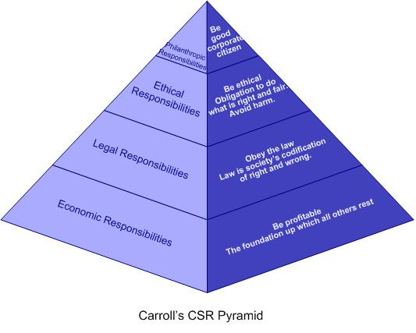
Figure 1: Carroll’s CSR Pyramid

2.5 CONSUMER BEHAVIOR THEORY
Phillip Kotler describes the behavior of consumers using the S-R Theory of consumer behavior model. This model of consumer behavior to demonstrate the motive that caused the decision to buy the product. The emotions of the buyer (Buyer's characteristic) depends on three factors,
2.5.1 Stimulus: focused on internal factors (The 4Ps) and external factors.
2.5.2 Buyer's Characteristics: external factors that influenced buyers decision Process
2.5.3 Buyer's decision process: consisting of problem recognition, Information search, Evaluation of alternatives and Post purchase behavior.

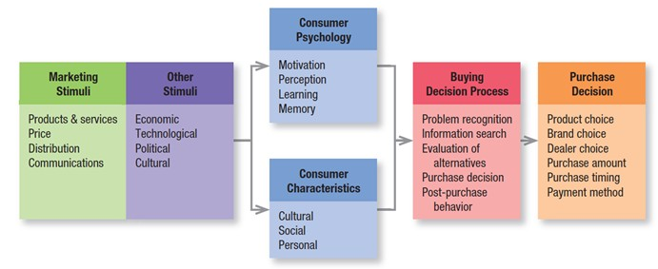
Figure 2: A Model of Consumer Behavior

2.6 Consumer Behavior in relation to CSR
Consumers do care about firms’ CSR but react toward firms’ CSR differently through their purchasing behavior. Consumers’ choices have implications for the whole society. Socially responsible corporations are more attractive to consumers. Consumers care about firms’ CSR and firms’ impact on environment. They reward and punish firms accordingly by choosing or exhibit aversion to firms’ products (Mohr et al., 2001). Additionally, “CSR is now a consumer purchase decision criterion” (Arli and Lasmono, 2009).
2.7 CONCEPTUAL FRAMEWORK

The four dimensions proposed by Carroll in 1991 (economic responsibility, legal responsibility, ethical responsibility, and philanthropic responsibility) served as the independent variables of this study. We explored whether or not these independent variables affect the intervening variables (brand trust, brand satisfaction, and brand attachment) and the dependent variables (current purchasing behavior and future purchasing intentions) with the final goal of conducting a comparative analysis of the differences between the X and Y generations. Our research framework is shown in Figure 3

Economic
Responsibilities
Legal
Responsibilities
Ethical
Responsibilities
Philanthropic
Responsibilities
Consumer Behavior

Figure 3: Conceptual Framework

2.8 RESEARCH HYPOTHESES

Null Hypotheses:
$H_{0}:$ Economic Responsibilities, Legal Responsibilities, Ethical Responsibilities, and Philanthropic Responsibilities do not significantly influence Consumer Behavior.

Alternative Hypotheses:
$H_{a}:$ Economic Responsibilities, Legal Responsibilities, Ethical Responsibilities, and Philanthropic Responsibilities significantly influence Consumer Behavior.

2.9 CONCEPT AND OPERATIONALIZATION OF VARIABLES
Table 1: Concepts and Operationalization of Variables
Variable | Operational  Definition | Source of References | Operational/  Questionnaire Items | Source of References | Type of  Data/Scale
Consumer Behavior | Consumer is the study “of the processes involved when individuals or groups select, purchase, use, or dispose of products, services, ideas, or experiences to satisfy needs and desires” | Solomon et al. (1995) | -The economic responsibility of the companies influence making purchase decision of products and services.  -The legal responsibility of the companies influence making purchase decision of the products and services.  -The Ethical responsibility of the companies influence making purchase decision of the products and services.  -The Philanthropic responsibility of the companies influence making purchase decision of the products and services. | Brown, T.J., & Dacin, P.A. (1997),  Creyer, E. H., & Ross (1997),  Mohr, L. A., Webb, D. J., & Harris, K.E., (2001) | Interval data, 5-points,  Likert Scale
Economic Responsibilities | To provide goods and services to society. Be committed to being profitable as possible; maintain a strong competitive position; maintain a high level of operating efficiency; and that a successful firm be defined as one that is consistently profitable | Carroll.(1991) | -Business should be committed to being profitable as possible.  -Business should maintain a strong competitive position.  -Business should maintain a high level of operating efficiency | Carroll(1991), (Elkin, 2007; Yilmaz & Gunel, 2008), (Kemper et al., 2013; Michelon et al., 2013). | Interval data, 5-points,  Likert Scale
Legal Responsibilities | To perform in a manner consistent with expectations of government and law; be a law-abiding corporate citizen; provide goods and services that meet minimal legal requirements; and that a successful firm be defined as one that fulfils its legal obligations. | Carroll.(1991) | -Business should perform in a manner consistent with expectations of government and law.  -Business should be a law-abiding corporate citizen.  -Business should provide goods and services that meet minimal legal requirements | Fombrun et al., (2010); Mallin & Michelon, (2011); Michelon et al.,(2013), Grossman, (2005); Falck & Heblich, (2007); Dobers & Springett, (2010) | Interval data, 5-points,  Likert Scale
Ethical Responsibilities | Activities and/or practices that, even though are not codified into law, are prohibited by societal members. | Carroll. (1979) | -Business should perform in a manner consistent with societal expectations and ethical norms.  -Business should recognise and respect new or evolving ethical/moral norms adopted by society.  -Business should prevent ethical norms from being compromised in order to achieve corporate goals. | Crane&Matten,(2010);Ghillyer, (2012) | Interval data, 5-points,  Likert Scale
Philanthropic Responsibilities | To perform in a manner consistent with philanthropic and charitable expectations of society, and voluntarily assist projects that enhance a community's quality of life | Carroll.(1991) | -Business should contribute resources to the community.  -Business should perform in a manner consistent with the philanthropic and charitable expectations of society.  -Business should voluntarily support projects that enhance the community's quality of life. | Carroll.(1991) | Interval data, 5-points,  Likert Scale

CHAPTER 3: RESEARCH METHODOLOGY

3.1 RESEARCH DESIGN

This study is a descriptive research, by using the questionnaire to gather the information from the sample group.

3.2 TARGET POPULATION AND SAMPLE

3.2.1 POPULATION
The target population in this study will be all DTAC customers.

3.2.2 SAMPLE SIZE
The number of customers of DTAC customers cannot be identified, therefore sample size will be determined by using the formula for unknown population developed by Berenson (1999).

Given that:
n is sample size
Z is Z score based on researcher desire level of confidence is 95 % therefore, z = 1.96
P is the proportion of correction. According to the population parameter, as the past information and relevant experience is not available, the researcher determine the value that will make p (1-p) as large as possible.
E is an acceptable sample error which be estimated at 5 %

$$n=\frac{Z^{2}pq}{E^{2}}$$
$$n=\frac{{1.96}^{2}(0.5)(0.5)}{{0.05}^{2}}$$
$$n=384.16$$
Therefore, the required sample for this study is 385.

3.3 SAMPLING TECHNIQUE

The data would be collected on the basis of convenience. The researcher will conduct the research at some famous department store. At first, the researcher will ask the participant whether they are the DTAC customers and they are willing to do the survey or not. If their answer is yes then the researcher will ask them to answer the questionnaire.
Also, the researcher will create an online questionnaire with a screening question that you are DTAC customers or not. Then the researcher will try to share the link to that online questionnaire to many people as much as possible.

3.4 RESEARCH INSTRUMENT

A self-made questionnaire was developed with the close-ended questions. The participants will have to rank their answer from strongly agree, agree, neutral, disagree, and strongly disagree.
The questionnaire was divided into five parts which are Consumer Behavior, Economic Responsibilities, Legal Responsibilities, Ethical Responsibilities, and Philanthropic Responsibilities.

3.5 COLLECTION OF DATA

The researchers create an online questionnaire at https://www.surveymonkey.com/r/CCJ9CCV and send the link to 32 DTAC customers. At first the researcher will ask that person first whether he or she is a DTAC customer or not. If they are then the researchers will send the link for online questionnaire to them. At the of data collection process the researchers received back 32 online questionnaires.

3.6 DATA PROCESSING AND ANALYSIS

After collection data through online questionnaire, the researchers put the answers from the surveys into SPSS for analysis. All statistical procedures will be made through the SPSS program to ensure the accuracy.
At first Reliability is done in order to check the Cronbach’s Alpha which will be used to tell the accuracy of the questions because the questions that are used to test the same factors should give the same results.
Next the researchers will calculate mean and standard deviation for all dependent and independent variables to find out how most respondents will react to those questions.
And we will end up our analysis by conducting Multiple Linear Regression to find out whether Economic Responsibilities, Legal Responsibilities, Ethical Responsibilities, and Philanthropic Responsibilities can significantly influence Consumer Behavior or not.
CHAPTER 4: RESEARCH RESULT

4.1 RELIABILITY TESTING
After running the SPSS program to test for the reliability of the variables we found out that the Cronbach’s Alpha for Consumer Behavior, Ethical Responsibilities, and Philanthropic Responsibilities are greater than 0.7 which means that it is reliable according to Nunnally. Therefore, we run the reliability test again to find out Cronbach’s Alpha is some items are deleted and the results for Economic Responsibilities and Legal Responsibilities are in table 3 and table 4 accordingly. And we found out that Cronbach’s Alpha for Economic Responsibilities will be raised to 0.804 if we delete the first item in the questionnaire, and Cronbach’s Alpha for Legal Responsibilities will be raised to 0.645 if we delete the third item in the questionnaire.
As a result, we will delete the first item for Economic Responsibilities and the third item for Legal Responsibilities in order to increase the reliability of the questionnaire.

Table 2: Reliability Testing Result
Variables | Items | Reliability Coefficient  (Cronbach’s Alpha)
Consumer Behavior | 1. The economic responsibility of the companies influence making purchase decision of products and services.  2. The legal responsibility of the companies influence making purchase decision of the products and services.  3. The Ethical responsibility of the companies influence making purchase decision of the products and services.  4. The Philanthropic responsibility of the companies influence making purchase decision of the products and services. | 0.788
Economic Responsibilities | 1. Business should be committed to being profitable as possible.  2. Business should maintain a strong competitive position.  3. Business should maintain a high level of operating efficiency | 0.641
Legal Responsibilities | 1. Business should perform in a manner consistent with expectations of government and law.  2. Business should be a law-abiding corporate citizen.  3. Business should provide goods and services that meet minimal legal requirements | 0.505
Ethical Responsibilities | 1. Business should perform in a manner consistent with societal expectations and ethical norms.  2. Business should recognize and respect new or evolving ethical/moral norms adopted by society.  3. Business should prevent ethical norms from being compromised in order to achieve corporate goals. | 0.772
Philanthropic Responsibilities | 1. Business should contribute resources to the community.  2. Business should perform in a manner consistent with the philanthropic and charitable expectations of society.  3. Business should voluntarily support projects that enhance the community's quality of life. | 0.867

Table 3: Reliability Testing for Economic Responsibilities
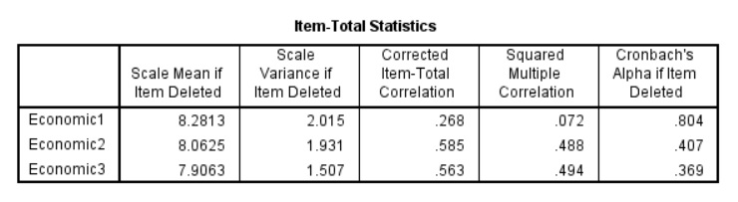

Table 4: Reliability Testing for Legal Responsibilities
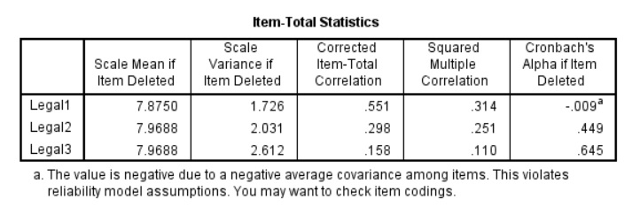
4.2 THE MEAN VALUES OF DEPENDENT AND INDEPENDENT VARIABLES
For the descriptive analysis of the dependent and independent variables, the arbitrary level was used in rating Consumer Behavior, Economic Responsibilities, Legal Responsibilities, Ethical Responsibilities, and Philanthropic Responsibilities. The mean scores of each variable can be interpreted into one out of five possible outcomes ranging from strongly disagree to strongly agree, as shown in table 5.

Table 5: Mean Score Interpretation
Level | Average Mean | Interpretation
Strongly Disagree | 1.00 – 1.79 | Strongly Disagree
Disagree | 1.80 – 2.59 | Disagree
Neutral | 2.60 – 3.39 | Neutral
Agree | 3.40 – 4.19 | Agree
Strongly Agree | 4.20 – 5.00 | Strongly Agree

Table 6: Respondents level for Consumer Behavior
Items | Mean | Std. Deviation | Interpretation
1. The economic responsibility of the companies influence making purchase decision of products and services. | 3.6563 | 0.86544 | Agree
2. The legal responsibility of the companies influence making purchase decision of the products and services. | 3.7500 | 0.91581 | Agree
3. The Ethical responsibility of the companies influence making purchase decision of the products and services. | 3.7500 | 0.84242 | Agree
4. The Philanthropic responsibility of the companies influence making purchase decision of the products and services. | 3.3438 | 0.82733 | Neutral
Consumer Behavior | 3.6250 | 0.67501 | Agree

Table 6 shows that most respondents agree to the Consumer Behavior. However, the respondents appear to be neutral on the question “The Philanthropic responsibility of the companies influence making purchase decision of the products and services”. And the overall mean is equal to 3.6250.

Table 7: Respondents level for Economic Responsibilities
Items | Mean | Std. Deviation | Interpretation
2. Business should maintain a strong competitive position. | 4.0625 | 0.66901 | Agree
3. Business should maintain a high level of operating efficiency | 4.2188 | 0.87009 | Strongly Agree
Economic Responsibilities | 4.1406 | 0.70977 | Agree

Table 7 shows that most respondents agree to the Economic Responsibilities. However, the respondents appear to be Strongly Agree on the question “Business should maintain a high level of operating efficiency”. And the overall mean is equal to 4.1406.

Table 8: Respondents level for Legal Responsibilities
Items | Mean | Std. Deviation | Interpretation
1. Business should perform in a manner consistent with expectations of government and law. | 4.0313 | 0.89747 | Agree
2. Business should be a law-abiding corporate citizen. | 3.9375 | 0.98169 | Agree
Legal Responsibilities | 3.9844 | 0.80807 | Agree

Table 8 shows that most respondents agree to the Legal Responsibilities. And the overall mean is equal to 3.9844.

Table 9: Respondents level for Ethical Responsibilities
Items | Mean | Std. Deviation | Interpretation
1. Business should perform in a manner consistent with societal expectations and ethical norms. | 4.0313 | 0.89747 | Agree
2. Business should recognize and respect new or evolving ethical/moral norms adopted by society. | 3.7187 | 0.92403 | Agree
3. Business should prevent ethical norms from being compromised in order to achieve corporate goals. | 3.7500 | 1.04727 | Agree
Ethical Responsibilities | 3.8333 | 0.79424 | Agree

Table 9 shows that most respondents agree to the Ethical Responsibilities. And the overall mean is equal to 3.8333.

Table 10: Respondents level for Philanthropic Responsibilities
Items | Mean | Std. Deviation | Interpretation
1. Business should contribute resources to the community. | 3.8750 | 0.94186 | Agree
2. Business should perform in a manner consistent with the philanthropic and charitable expectations of society. | 3.6875 | 0.85901 | Agree
3. Business should voluntarily support projects that enhance the community's quality of life. | 4.0313 | 0.8677 | Agree
Philanthropic Responsibilities | 3.8646 | 0.78908 | Agree

Table 10 shows that most respondents agree to the Philanthropic Responsibilities. And the overall mean is equal to 3.8646.

4.3 HYPOTHESIS TESTING
In this section the hypothesis was tested by using multiple linear regression method in order to understand whether Economic Responsibilities, Legal Responsibilities, Ethical Responsibilities, and Philanthropic Responsibilities significantly influence Consumer Behavior or not.
The research hypothesis was set up according to the objective of this research and conceptual framework as follows.
$H_{0}:$ Economic Responsibilities, Legal Responsibilities, Ethical Responsibilities, and Philanthropic Responsibilities do not significantly influence Consumer Behavior.
$H_{a}:$ Economic Responsibilities, Legal Responsibilities, Ethical Responsibilities, and Philanthropic Responsibilities significantly influence Consumer Behavior.

Since the study applied Multiple Linear Regression analysis to test the hypothesis, the formula of such analysis was applied.
Formula of Multiple Linear Regression
$$\hat{Y}=β_{1}X_{1}+β_{2}X_{2}+β_{3}X_{3}+β_{4}X_{4}+β_{0}$$
$\hat{Y}=$ Consumer Behavior
$β_{0}=$ Constant Value
$β_{1}=$ Unstandardized Coefficient of Economic Responsibilities
$β_{2}=$ Unstandardized Coefficient of Legal Responsibilities
$β_{3}=$ Unstandardized Coefficient of Ethical Responsibilities
$β_{4}=$ Unstandardized Coefficient of Philanthropic Responsibilities
$X_{1}=$ Economic Responsibilities
$X_{2}=$ Legal Responsibilities
$X_{3}=$ Ethical Responsibilities
$X_{4}=$ Philanthropic Responsibilities

Table 11: Multiple Linear Regression Result
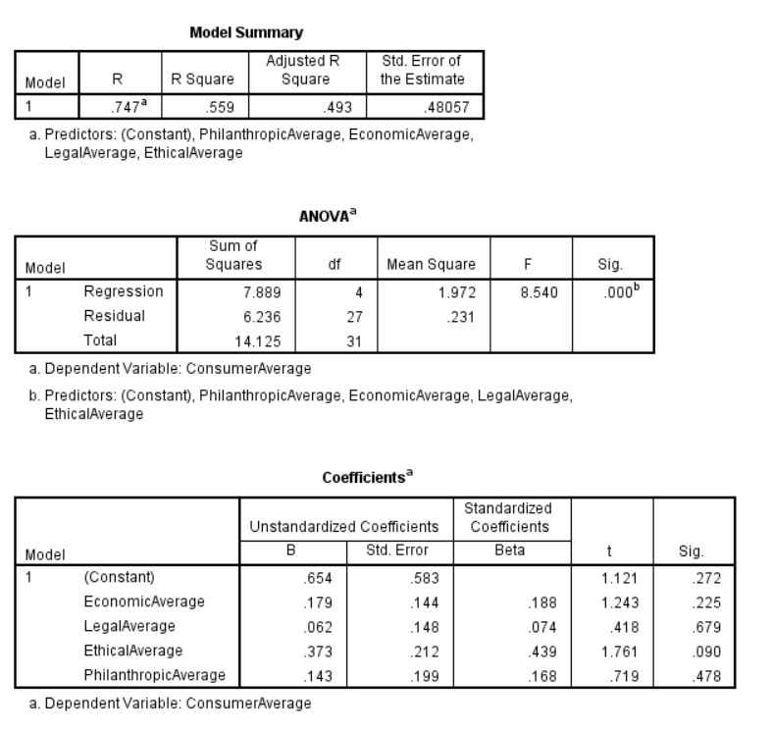
The predictors were Economic Responsibilities, Legal Responsibilities, Ethical Responsibilities, and Philanthropic Responsibilities and the criterion variable was Consumer Behavior. The result shows that R-square is equal to 0.559 which means that 55.9% of dependent variable can be explained by the independent variables. And the p-value is equal to 0.000, therefore, the null hypothesis was rejected, and the combination of Economic Responsibilities, Legal Responsibilities, Ethical Responsibilities, and Philanthropic Responsibilities indicated Consumer Behavior.
However, the coefficient table shows that each independent variables individually (not in combination) does not influence dependent variable because Economic Responsibilities Average Sig = 0.225 which means that it will be significant at 77.5% significant level, Legal Responsibilities Average Sig = 0.679 which means that it will be significant at 32.1% significant level, Ethical Responsibilities Average Sig = 0.090 which means that it will be significant at 91% significant level, and Philanthropic Responsibilities Average Sig = 0.478 which means that it will be significant at 52.2% significant level.

Bibliography

Alterman, S. (2008). Doing Better at Doing Good: When, Why and How Consumers Respond to Corporate Social Initiatives. California Management Review, 47(1), 9-24

Brown, T.J. & Dacin, P.A. (1997). The Company and the Product: Corporate Associations and Consumer Product Responses. Journal of Marketing, 61, 68–4.

Crowther, D. & Rayman-Bacchus, L. (2003) Perspectives on Corporate Social Responsibility. Crane, A. et al. (eds) The Oxford Handbook of Corporate Social Responsibility. Oxford University Press

Harris K.E., Mohr L.A. & Webb D.J. (2001). Do consumers expect companies to be social responsible? The impact of corporate social responsibility on buying behavior. Journal of Consumers Affairs p45.

Industry Canada (2012). Corporate Social Responsibility. Available: http://www.ic.gc.ca/eic/site/csr-rse.nsf/eng/rs00129.html

Kotler, P., Keller, K.L., Brady, M., Goodman, M. & Hansen, T. (2009). Marketing Management. Prentice Hall.

Morsing, M. & Beckmann, S.C. (2006). Strategic CSR Communication. Copenhagen: DJOF.

Sen, S. & Bhattacharya C. B. (2001). Does Doing Good Always Lead to Doing Better? Consumer Reactions to Corporate Social Responsibility. Journal of Marketing Research, 38, 225–243.

DTAC. History. April 13, 2016. Retrieved from https://www.dtac.co.th/en/about/history.htm
The Nation technology. November 18, 2009. DTAC's "Do Good Deeds Every Day" CSR project wins SET Award. Retrieved from http://www.nationmultimedia.com/2009/11/18/technology/technology_30116864.php
DTAC. Articles, June 25, 2012. dtac wins ICT awards 2011. Retrieved from https://www.telenor.com/media/articles/2012/dtac-wins-ict-awards-2011/
Ki-Han Chung Ji-Eun Yu Myeong-Guk Choi Jae-Ik Shin, (2015), The Effects of CSR on Customer Satisfaction and Loyalty in China: The Moderating Role of Corporate Image, Journal of Economics, Business and Management, Vol. 3, No. 5, May 2015
Lynette M. McDonald Chia Hung Lai, (2011), Impact of corporate social responsibility initiatives on Taiwanese banking customers. International Journal old Bank Marketing, Vol. 29 Iss 1pp. 50-63
Carroll, A. B. (1979). A three-dimensional conceptual model of corporate performance. Academy of Management Review, 4(4), 497–505.
Carroll, A. B. (1991). The pyramid of corporate social responsibility: toward the moral management of organisational stakeholders [Electronic version]. Business Horizons, July–August, 39–47.
Leon G. Schiffman, Leslie Lazar Kanuk, Joseph Wisenblit. (2011). Consumer behavior. Pearson Prentice Hall.

